**Capstone Project**

**Background.**

There are two places that I like the most in New York city. one is Long Island, and other one is Manhattan.

Manhattan , often referred to by residents of the New York City area as the City, is the most densely populated of the five [boroughs of New York City](https://en.wikipedia.org/wiki/Boroughs_of_New_York_City), and coextensive with the County of New York, one of the [original counties](https://en.wikipedia.org/wiki/List_of_counties_in_New_York) of the [U.S. state](https://en.wikipedia.org/wiki/U.S._state) of [New York](https://en.wikipedia.org/wiki/New_York_(state)). Manhattan serves as the city's economic and administrative center, [cultural](https://en.wikipedia.org/wiki/High_culture) identifier, and historical birthplace. The borough consists mostly of Manhattan Island, bounded by the [Hudson](https://en.wikipedia.org/wiki/Hudson_River), [East](https://en.wikipedia.org/wiki/East_River), and [Harlem](https://en.wikipedia.org/wiki/Harlem_River) rivers; as well as [several small adjacent islands](https://en.wikipedia.org/wiki/List_of_smaller_islands_in_New_York_City).

Long Island is a densely populated island in the southeast part of the [U.S. state](https://en.wikipedia.org/wiki/U.S._state) of [New York](https://en.wikipedia.org/wiki/New_York_(state)), in the [northeastern United States](https://en.wikipedia.org/wiki/Northeastern_United_States). At [New York Harbor](https://en.wikipedia.org/wiki/New_York_Harbor) it is approximately 0.35 miles (0.56 km) from [Manhattan Island](https://en.wikipedia.org/wiki/Manhattan) and extends eastward over 100 miles (160 km) into the [Atlantic Ocean](https://en.wikipedia.org/wiki/Atlantic_Ocean). The island comprises four [counties](https://en.wikipedia.org/wiki/County_(United_States)); Kings and Queens counties (the [New York City](https://en.wikipedia.org/wiki/New_York_City) [boroughs](https://en.wikipedia.org/wiki/Borough_(New_York_City)) of [Brooklyn](https://en.wikipedia.org/wiki/Brooklyn) and [Queens](https://en.wikipedia.org/wiki/Queens), respectively) and [Nassau County](https://en.wikipedia.org/wiki/Nassau_County,_New_York) share the western third of the island, while [Suffolk County](https://en.wikipedia.org/wiki/Suffolk_County,_New_York) occupies the eastern two thirds. More than half of New York City's residents live on Long Island, in Brooklyn and in Queens.

**Problem**

However, I want open a restaurant, which place or neighborhoods is better. In order to find out the problem. First, I need explored Manhattan and Long Island data by use segmented and clustered their neighborhoods. Second, I will use the explore function to get the most common venue categories in each neighborhood, and then use this feature to group the neighborhoods into clusters. Also, use the k-means clustering algorithm to complete this task.

**Data**

The dataset includes three attributes borough, neighborhood, latitude, longitude.

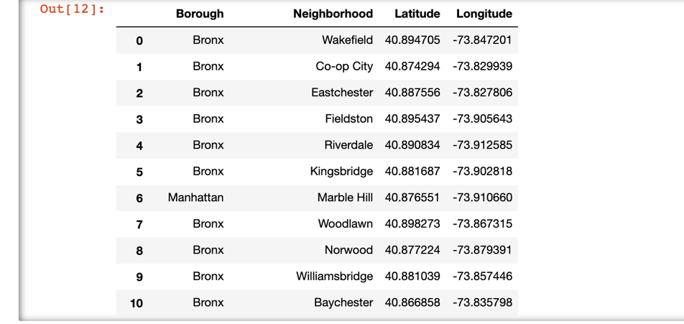

Use API foursquare to find all the restaurant data.

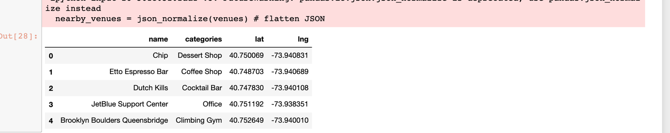

**Reference**

<https://en.wikipedia.org/wiki/Long_Island>

https://en.wikipedia.org/wiki/Manhattan